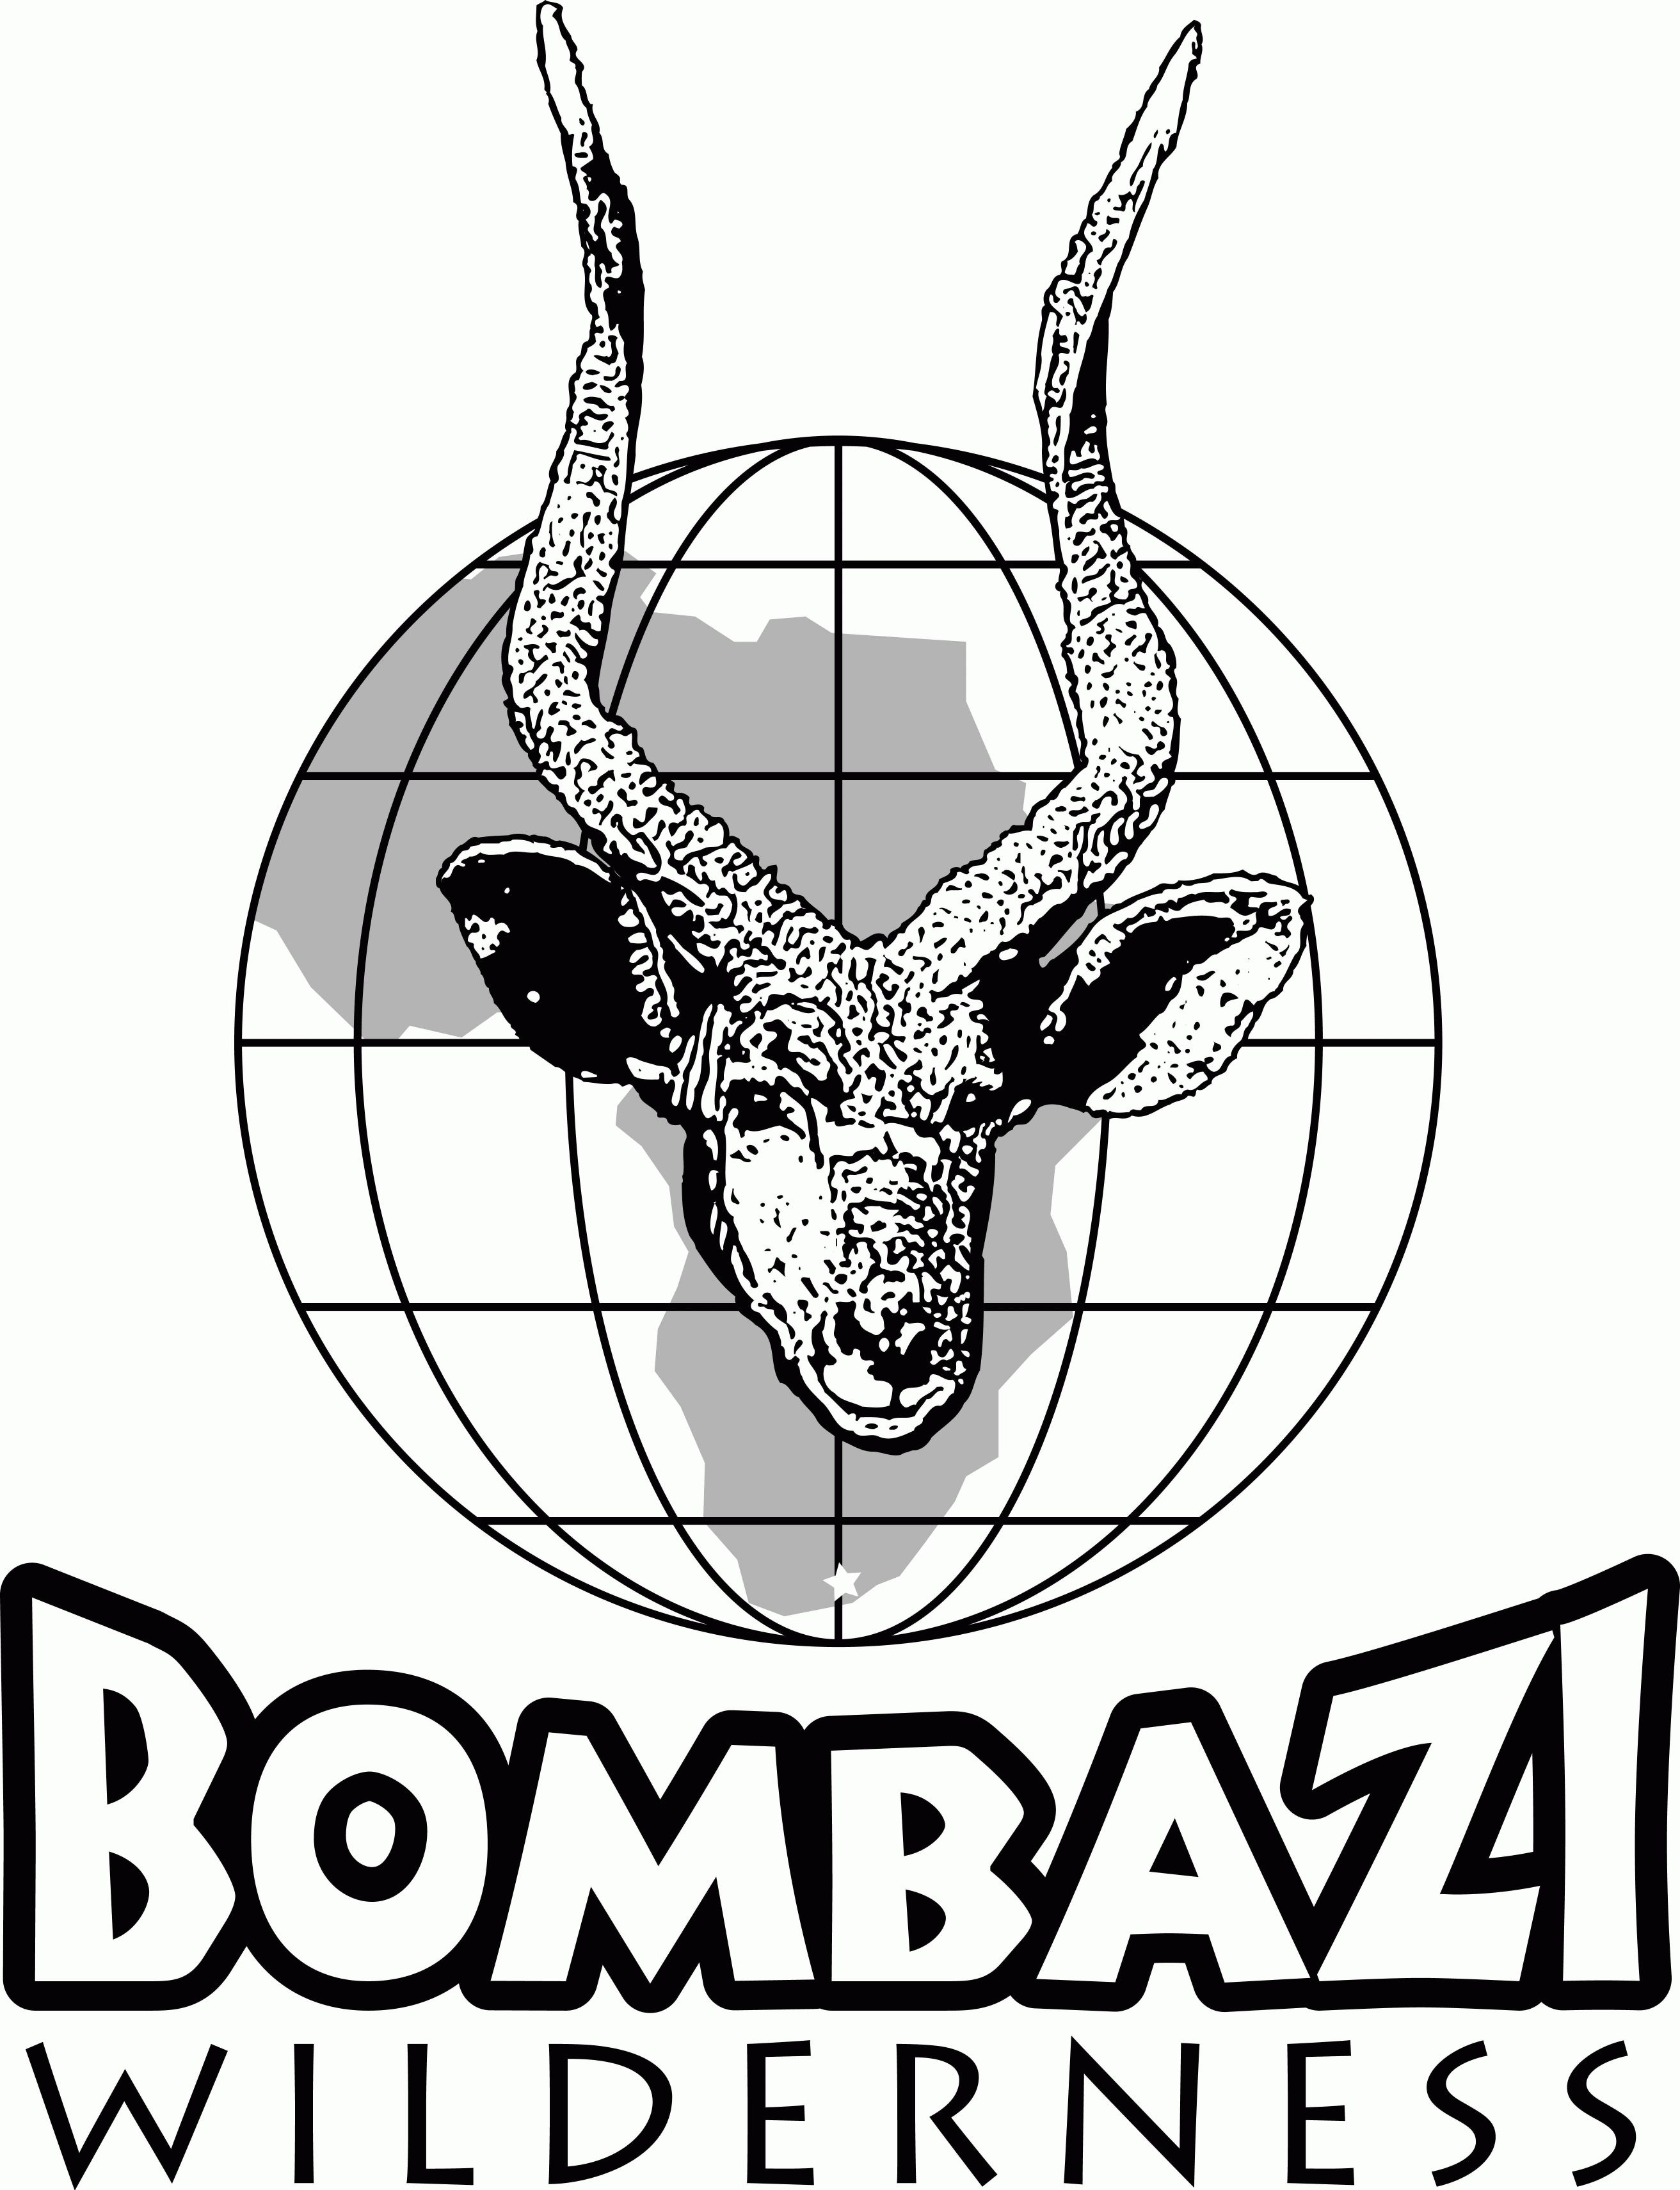

BOMBAZAI WILDERNESS
EASTERN CAPE, SOUTH AFRICA
PRICE LIST FOR 2007

Daily hunting rate
Animal | Trophy fee $
Blesbuck | 400
Black Wildebeest | 900
Bushpig | 500
Cape Bushbuck | 650
Caracal (lynx) | 300
Duiker - Southern | 300
Eland- Cape | 2000*
Gemsbuck | 1100*
Impala - Southern | 340
Kudu - Cape | 1000*
Nyala | 2100*
Ostrich | 400
Oribi | 1000*
Reedbuck - Common | 900
Reedbuck - Mountain | 450
Red Hartebeest | 950
Red Lechwe | 2800
Springbuck | 380
Waterbuck - common | 2000*
Vaal Rhebuck | 1000*
Zebra - Burchells | 1100*
Zebra - mountain | POR
$300/ day (1X1) and $250/day (2X1)
Includes all non-hunting items plus:
Permits and licenses, PH with vehicle, tracker, skinning of the animals for a shoulder mount, salting of the cape and transport to the taxidermist

Non-hunting daily rate
$150/day includes:
Accommodations, food, drinks, alcohol in moderation, laundry, transportation to and from East London airport as well as on the property, use of the horses, trails

Not included in rates:
Tips, packing and dipping of trophies, taxidermy fes,
transportation to/from East London, personal items
14% tax on daily rate.
Trips off the property.

A list of desired species should be made available as soon as you are aware of what you wish to hunt. Other species may be available on a request basis.

OWNERS
Cam & Brian Greig 650-948-4560 cam.greig@yahoo.com

* Only one animal with a value of over $750 may be collected on hunts of less than 7 days in duration. Two animals over $750 may be collected on trips of 10 days, and three with trips over 14 days. Wounded animals must be paid for as harvested animals.

Permit # CR01 / 06 / 03 HC 07 / 2005

