

Bombazi Wilderness offers hunting and/or photography safaris for South Africa Plains Game as well as equestrian programs, birding and nature walks for enjoying the wonders of South Africa. With over 20 different species of animals available, see our Trophy List, your safari will be an experience of a lifetime. The professional staff will ensure your stay is comfortable and rewarding. Be sure to check out our all inclusive safari package deals!

Location: The Bombazi Wilderness is in the Eastern Cape Province of the Republic of South Africa. Located between East London and Queenstown, it is in a secluded area which provides a perfect natural habitat for the Plains Game species you will encounter on your safari. This is a malaria free area. There are no shots or visa required. There are no dangerous game, the Big 5 species, on the Bombazi Wilderness however if you wish to include any of these on your safari, arrangements can be made. See our Trophy Fees for a list of the Plains Game animals available.

Hunting Season: The hunting seasons are from April through October, which allows for the most favorable weather conditions. The early season is still warm days with cool evenings. The mid season has cold nights, close to freezing, and warm days, and the late season is warmer but windy.

Accommodations: Bombazi Wilderness offers a comfortable lodge with modern facilities, hot and cold water, generated electricity and gas. The staff will cater to your every need, including daily laundry. The meals are great and personal service superb. The lodge gardens are beautiful. Local trees and plants are identified around the garden as well as throughout the wilderness for your information and understanding of the native trees and plants. Day trips can be arranged for sightseeing, shopping or other desires.
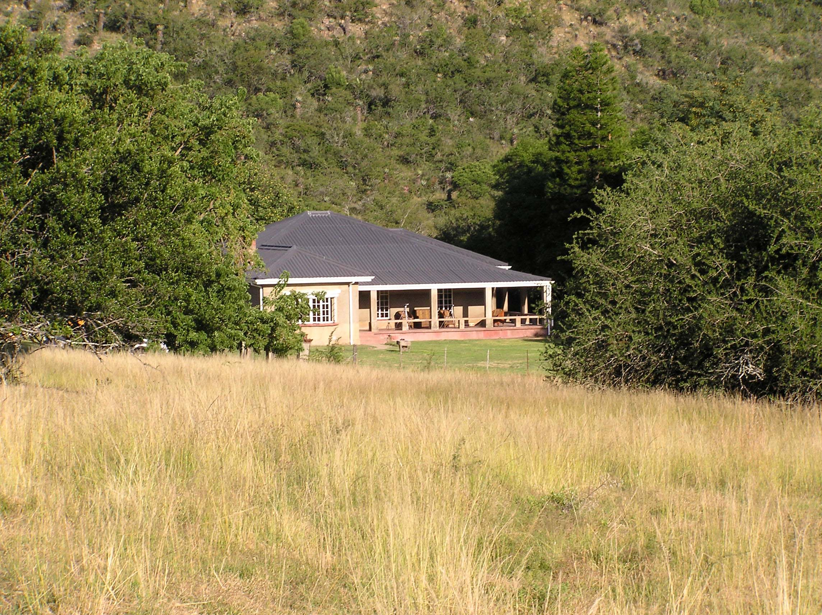

Professional Hunter: You will be provided with a trained, licensed, and knowledgeable Professional Hunter, PH and native tracker to ensure your safari is enjoyable and successful. They will at all times maintain firearm safety, a high standard of ethics, and sportsmanship in the spirit of fair chase. They will also ensure the care of your trophies.
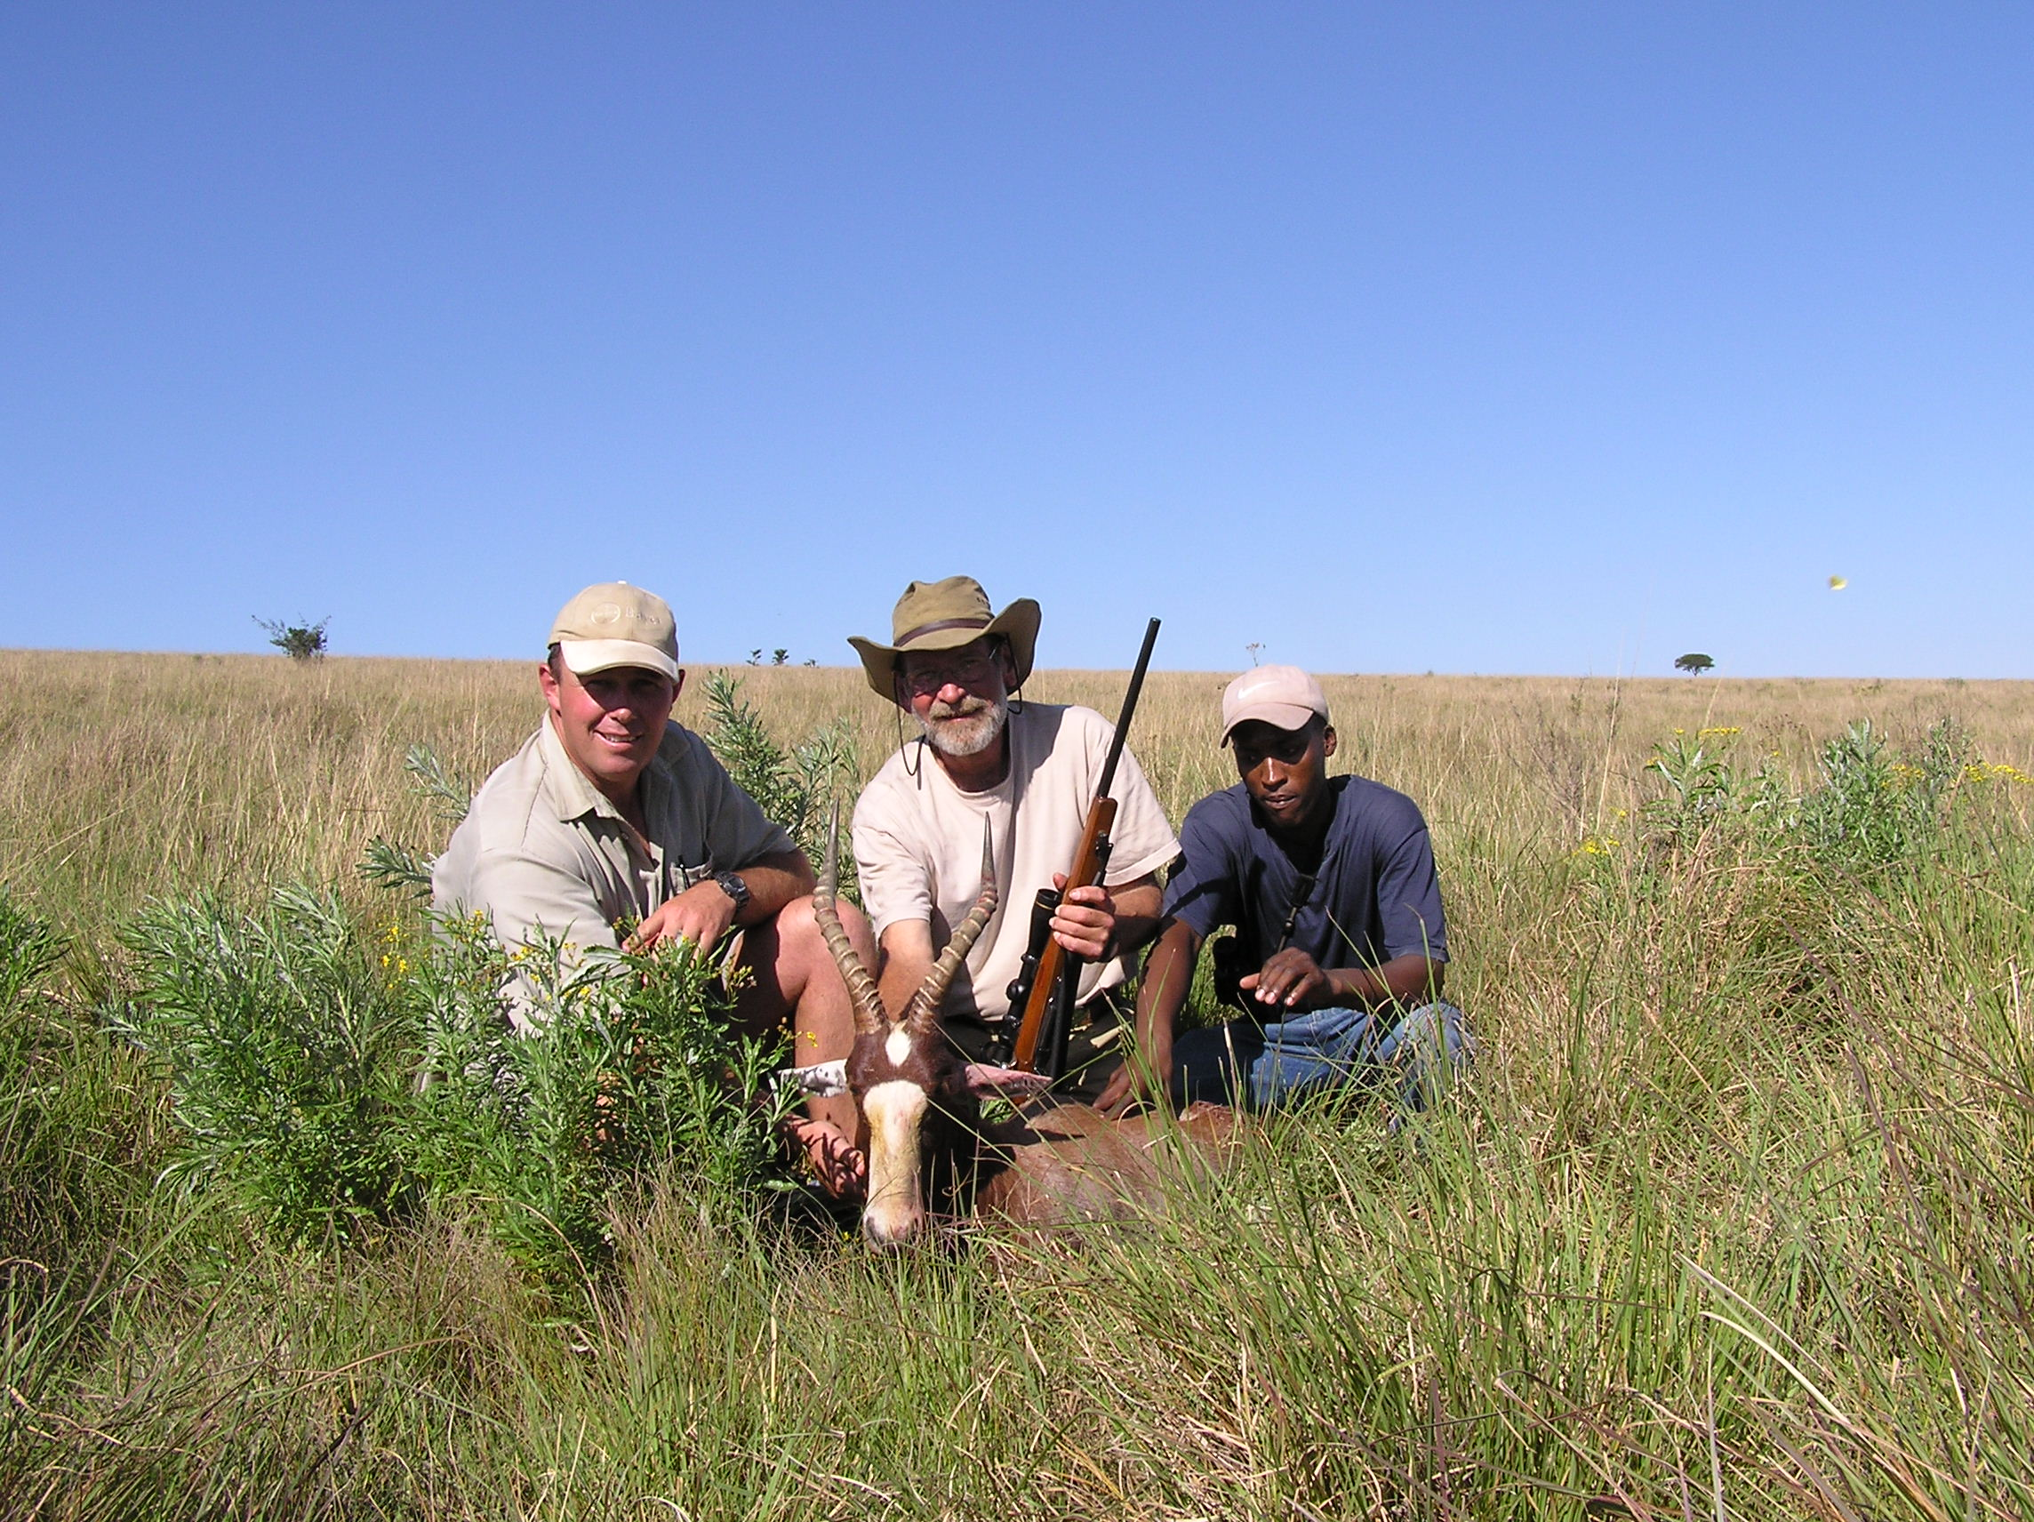
Guest Preference List: Soon after booking your Bombazi Wilderness Safari you should provide a list of desired trophies you wish to hunt and/or photograph. Other species may be available upon request. Also please indicate any special desires, dietary requirements, or needs as to food, drink and accommodations you may have. This will allow us to ensure your safari is the most enjoyable and comfortable as possible.

Terms of Business: A 50% deposit of the Daily Rate is required at the time of booking your safari. The balance of the Daily Rate is due before your departure. It is also necessary to pay all Trophy Fees on package hunts and/or for pre-arranged Trophies before departure, this is to avoid carrying large sums of cash or travelers checks. Personal checks, casher checks and cash are acceptable for payments. Arrival and departure days are considered one day combined. There is a minimum stay of five (5) days. Value Added Tax (VAT) is charged on the daily rate. VAT is also charged for animals in a package that are not hunted or animals that are wounded and lost. All additional fees for side trips will be billed at upon your return. Booking Deposits are not refundable unless cancellation is received 90 days before the start of your safari and a 15% cancellation fee shall apply at that time.

Liability: Bombazi Wilderness will take the utmost care to ensure your safety and that of your belongings while on your safari, however we take no responsibility including negligence for personal injury, accidents or illness, including death, and loss of property. All quests will be asked to sign a Waiver of Liability, Assumption of Risk, and Indemnity Agreement on arrival

How to contact us: To book your Bombazi Wilderness safari, contact the owner Cam Greig at cam.greig@yahoo.com

Permit # CR01 / 06 / 03
HC 07 / 2005

